CSS Cascading style sheet

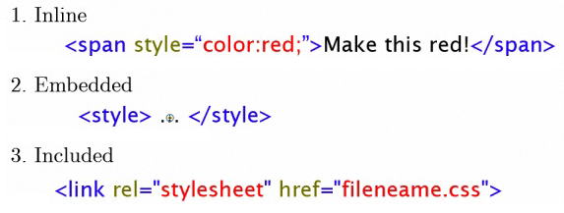

**SELECTORS**

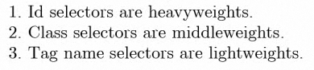

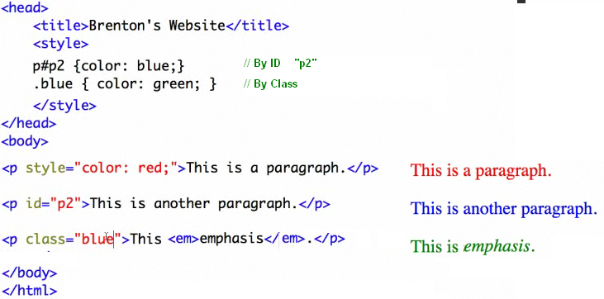

Class blue is applied to “p” elements only



Apply font color purple to the paragraphs inside a div



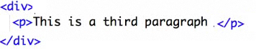

Apply font color purple to the emphasis (em) inside a paragraph inside div



You can assign multiple classes to an element



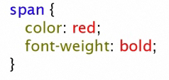



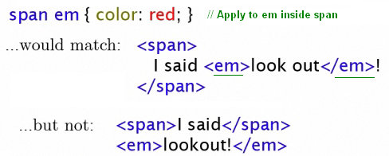

RULE ORDER

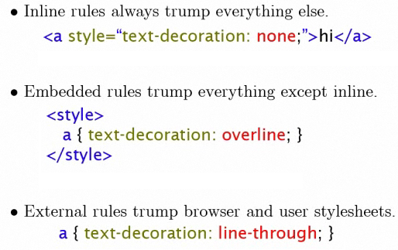

**CONFLICT : WINS THE MORE SPECIFIC**



**BORDER**

**border:** solid 1px #CCC;

**border-top:** solid 1px #CCC;

**border-bottom:** solid 1px #CCC;

**border-left:** solid 1px #CCC;

**border-right:** solid 1px #CCC;

**FONT**

**font-family:** Times New Roman;

**font-size:** 17px;

**font-style:** normal; // italic, oblique, etc

**font_weight:** normal; // inherit, lighter, bold

**LETTER**

**letter-spacing:** 1px; // space between letters

**line-height:** 16px;

**margin-left:** 20%;

**margin-right:** 20%;

**TEXT**

**text_align:** left; // right, center, justify

**text-decoration:** none; // **blink, line-through overline, underline**

**text-indent:** 0; // only first line is indented

**text-indent:** none;

**text-shadow:** 1px 3px 3px green; // offset up, offset left

**text-shadow:** black 0.1em 0.1em 0.2em;

**text-transform:** none; // lowercase, capitalize

**WORD**

**word-spacing:** 3px // spacing between words

**word-wrap:** break-word; // normal

<http://www.csscompressor.com/>

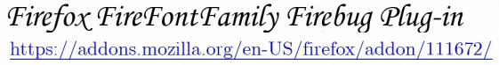

**SITE-WIDE FONT SETTINGS**

1. Make all fonts to a default font

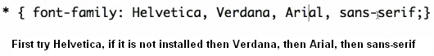

2. Make all heading fornts default to a cursive font (use (“) when the font has a space)

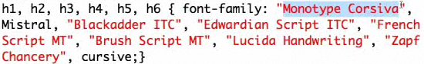

1. Justify paragraphs



1. Increate the line-height of paragraph



**BIG FIRST LETTER**

1. Make the first letter of the first paragraph bigger



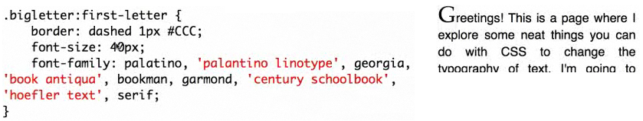

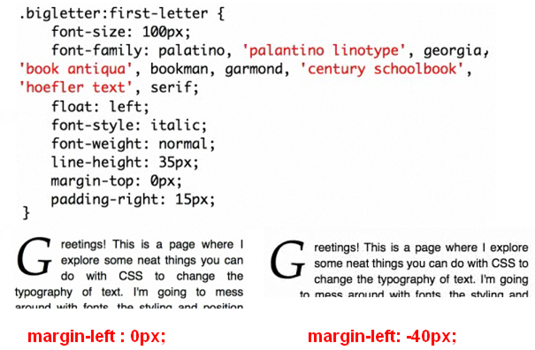

1. Position the first **2 lines** of the text to wrap araound the first letter

Set in the prevous font-size: 80px instead of 100px

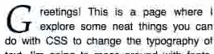

1. Align the botton of the first letter with the baseline of the second letter

Set the previous pargin-top: 5px instead 0px;

**FUN QUOTES**

Stylize the **quote** in a interesting font and color. Add a graphical quote flair and use a reverse indentation for fun

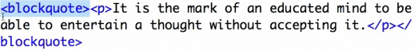

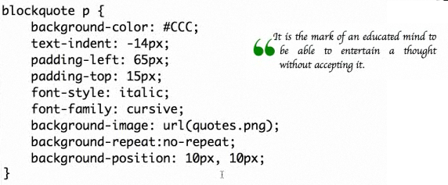

**BREAKING LONG WORDS**



**RAINBOW**

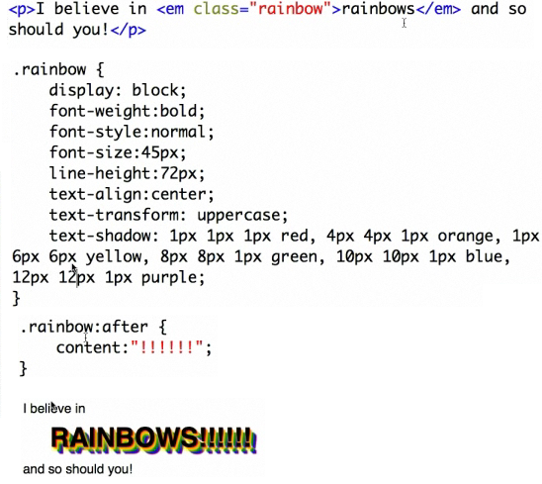

craigslist.org

monster.com

dice.com

chamber

meatup.com